Chinese Government Scholarship Application

1. How can I get the latest information about Chinese Government Scholarship?
You can get the up-to-date scholarship information by visiting www.campuschina.org or www.csc.edu.cn/laihua. You can also consult the Chinese Embassy (Consulate General) in your home country or designated Chinese universities for your interested information.

2. What programs can I apply for? When and where can I apply?
The application opens between early January and early April. You should apply and send the required documents to the application receiving agencies before the deadline. The table below tells you when and where to send your applications.

Scholarship programs | When to apply | Where to send the application | Supporting category | Scholarship coverage
Bilateral Program | Early January to early April (please consult the application receiving agencies for specific deadline for each program) | dispatching authorities of applicant’s home country | undergraduate students  master’s students  doctoral students  general scholars  senior scholars | full scholarship
Chinese University’s Independent Enrollment Program |  | designated Chinese universities | master’s students  doctoral students | full scholarship
Great Wall Program |  | National Commissions for UNESCO in applicant’s home country | general scholars  senior scholars | full scholarship
EU Program |  | Office for Education and Culture, Mission of P. R. China to EU | undergraduate students  master’s students  doctoral students  general scholars  senior scholars | full scholarship
AUN Program |  | AUN Secretariat | master’s students  doctoral students | full scholarship
PIF Program |  | PIF Secretariat | undergraduate students  master’s students  doctoral students  general scholars  senior scholars | full scholarship
WMO Program |  | WMO Secretariat | undergraduate or graduate students of meteorology, hydrology, and water resources supervision & management. | partial scholarship

3. What are application steps of Chinese Government Scholarship?
The illustration below may help you understand the general application steps. There might be minor differences between programs. Please read the introductions to each program for detailed guidance.

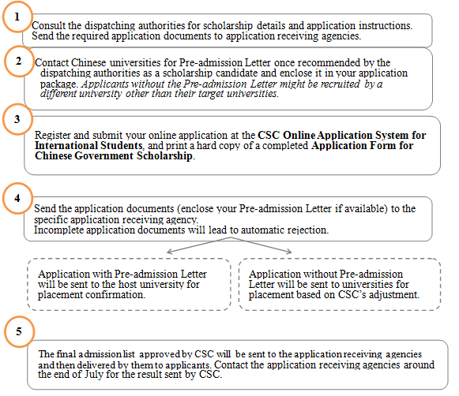

4. Can I apply for Chinese Government Scholarship without Admission Letters?
Yes. The Pre-admission Letter from a Chinese university is not a necessary application material. Applications enclosed with the Pre-admission Letter will be sent directly to the host universities for placement confirmation. Applications without the Pre-admission Letter will be sent to universities to go through admission procedure. For applicants without the Pre-admission Letter, CSC cannot assure the host university will be one of the preferences of institution, since the capacity of the universities and the eligibility of the applicants will also be considered.

5. Does the Letter of Acceptance or email from the supervisor equal to the Pre-admission Letter?
No. Only the Pre-admission Letters (or Admission Letters) issued by the admissions office of designated Chinese universities are considered valid. Other files like acceptance letters from potential supervisors or emails from supervisors or professors shall not be regarded as the equivalent or substitute.

6. What is “Agency Number” and where can I get it?
Agency Number is the first required item that must be filled when applying online at CSC Online Application System for International Students. Each Agency Number stands for a specific application receiving agency and will be given to the recommended candidates only. A correct Agency Number will lead to the presence of the corresponding application receiving agency while a wrong one will lead to the application rejection. You will only get your Agency Number from your application receiving agency (e.g. Chinese embassy, AUN Secretariat, etc.) when you are recommended as a candidate.

7. How can I login the CSC Online Application System for International Students?
① Go to www.csc.edu.cn/laihua or www.campuschina.org, and click the icon “Application Online for International Students” to enter the system.
②First-time users should register before entering the online application page.
③Please use Internet Explorer (6.0 or 7.0). Menu selection functions may not work in other browsers.

8. What do I need to pay special attention to when applying online?
①Please select the program CHINESE GOVERNMENT SCHOLARSHIP.
②The item Apply for refers to the program you want to study rather than the degree you have already held.
③Majors should be one of the existing majors offered by Chinese universities and be based on your actual educational background. A nonexistent or improper major input will affect your application result.
④Preference of Institutions must be chosen from 279 Chinese universities designated by MOE. Any institution beyond the list will not be available for recruitment.
⑤Duration of the Major Study should match the program you apply for. Please check introductions to each program for the specific schooling period.
⑥ Submitted applications can be retrieved for revision. Once retrieved, the previously submitted application becomes invalid. Therefore, revised application should be submitted one more time.

9. How to write a Study Plan or Research Proposal?
A Study Plan or Research Proposal states in details what you are going to do with the scholarship in China. It must include such information as the major you want to study in or the field of your research interest. It is of vital importance for those applicants for the graduate studies or senior scholar programs, so please make sure your study plan or research proposal states those information as specific as possible.

10. What supporting documents should be included in my application package?
Generally, applicants must fill in and provide the following documents truly, correctly and completely (in duplicate).
①Application Form for Chinese Government Scholarship (in Chinese or English)
②Notarized highest diploma
③Academic transcripts
④A study plan or research proposal
⑤Recommendation letters
⑥Applicants for music studies are requested to submit a CD of the applicants’ own works. Applicants for the fine arts programs must submit a CD of the applicants’ own works (including two sketches, two color paintings and two other works)
⑦Applicants under the age of 18 should submit the valid documents of their legal guardians in China.
⑧Applicants planning to stay in China for more than 6 months must submit a photocopy of Foreigner Physical Examination Form ( valid for 6 months).
⑨Applicants with the Pre-admission Letter/Admission Letter from designated universities should enclose the letter in the application package.
⑩Applicants with valid HSK Certificate should enclose the photocopy of it in the application package.
The above documents should be bound on top left corner (in duplicate) in order. No application documents will be returned.

11. Do I have to register for Chinese-taught programs?
①If you are an undergraduate student, you must register for Chinese-taught credit courses. If your Chinese language proficiency does not meet the requirements of your host university, you must take one academic year Chinese language/preparatory courses in one of the 10 designated universities and pass the required tests before moving on to your major studies. Failure to pass the required tests will lead to the automatic termination of your scholarship.
②If you are a graduate student or a non-degree student, you can register for either the Chinese-taught program or the English-taught program if applicable. You can check Program Search (By visiting http://www.csc.edu.cn/laihua or http://www.campuschina.org) to find your interested program. Scholarship recipients of Chinese-taught programs without adequate Chinese language proficiency must take Chinese language training courses for one to two academic years to reach the language requirements of their host universities before moving on to major studies. Failure to reach the required language proficiency will lead to the termination of scholarship. Recipients in programs such as Science, Engineering, Agriculture, Medicine (Western Medicine), Economics, Management, Legal Studies and Fine arts will take Chinese courses for one academic year. Recipients of Literature, History, Philosophy and Chinese Medicine will take Chinese courses for no more than two academic years. Scholarship students of the English-taught program or with adequate Chinese language proficiency (with valid HSK certificate) do not need to take Chinese language training courses.

12. Which Chinese universities are under the Chinese Government Scholarship scheme?
A total of 279 Chinese universities are designated by MOE to accept Chinese Government Scholarship students from which you can choose your target university. You can go to http://www.csc.edu.cn/laihua or http://www.campuschina.org for programs and universities available.

13. Can I apply directly to Chinese universities for Chinese Government Scholarship?
Only the 279 designated Chinese universities under the CGS-Chinese University Program can directly accept individual scholarship applications. You can search your interested university at http://www.csc.edu.cn/laihua or http://www.campuschina.org.

14. Can I apply for more than one scholarship program?
Yes, but each scholarship recipient can be granted with no more than one scholarship. CSC reserves the right to grant only one scholarship to each individual recipient.

15. How can I know the admission result?
The admission result will be announced by the application receiving agencies in late July. You can consult the application receiving agencies for admission result then.

